Sophie’s World by Jostein Gaarder
Summer Reading for AP English Literature and Composition Students

Note: A copy of this assignment can be found on the AP Literature & Composition page of our class website at this link: http://2readornot2read.weebly.com/about-ap-english-iv-literature--composition.html

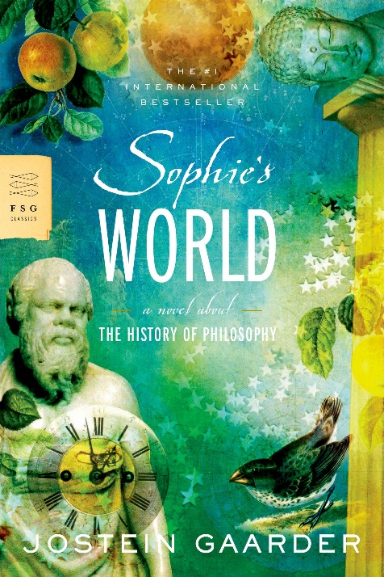
Due Date: Friday – 1st week of school

This Summer: Read the novel Sophie’s World and complete the assignments in this packet. Please take my advice and work as you read; trying to read the entire book first and then do this assignment will end in disaster. I also suggest that you annotate the text or take notes as you read, and consider discussing the text with your peers as well. A blog will be set up on our class website so that you can discuss the novel with your peers online, bounce around ideas and receive feedback. The link to the blog is: http://2readornot2read.weebly.com/book-blog

Your Reading: More advice about reading: this book can be dense; that is, it can be hard to understand too much of it at one sitting. Give yourself a good four to five weeks* to read and complete this assignment. If you’d rather do it early than later in the summer, please review the book and the assignment before the due date in order to refresh your memory. (*This estimate has been validated by AP students who have read this book before you).
Assignment Rationale: No book is ever written in a void. All authors belong to their historical time (some to all time), and the beliefs and philosophies of their times often have an influence on their books. In order for us to have a more fully developed world view, we read this novel, in which Jostein Gaarder hopes to teach us something about basic Western philosophy. I believe that if we have a basic grasp of philosophers' questions, we will also have an understanding of artists' questions, for they are often the same. By improving our view of the history of thought, we will improve our view of literary history by default. Also, it is always a good idea to improve our view of history in order that we may have a more global, less solipsistic view of our own existence.
ISBN - 10: 0374530718
$5.63 on Amazon.com
AP Expectations (or if you have decided to not read this novel, read this): If you have decided to not read this novel, read this: Perhaps honor and integrity are passé. I hope not. I can also understand being busy, but to shrug off a book because it's 500 pages or because it would simply be easier to cheat is either lazy or dishonest. To be a member of the AP class requires integrity. You will be expected to read and think and express that thinking verbally and in writing. Believe it or not, it will be clear who has read the books and who has not. Furthermore, there is little I can do to prepare students for a rigorous test if they are not willing to do the work required for success. And students who are not willing to do the work should honestly think about their motives for being in a rigorous class. If you think you are someone who will try to get by and fake your way through, you should see your counselor as soon as possible to switch into another English elective.

Final Thoughts: As you’re reading Sophie’s World, you may find you disagree with some of Gaarder’s characters and their views (or you may not). Either way, please remember that good literature not only evokes an emotional response (good or bad) but also makes us think. In fact, most literature deals on some level with the questions brought forth in Sophie’s World (the ones that plague mankind): Who am I? Why am I here? Etc., etc. Remember, each philosophy is simply a theory that attempts to explain one or more of these big questions. You may have your own philosophy or belief system that explains these questions; and, you are more than welcome to disagree with individual philosophers. You can rest assured that we will discuss the philosophical ideas when you return to school and we will tackle Gaarder’s seeming bias towards certain ideas.

Questions: If you have any questions over the summer as you grapple with Sophie’s World, the assignment, and the many philosophical ideas. Feel free to call me or text me at 303-653-3700. You may also email me at alholder@adams14.org, but I do not often check my work email over the summer, so, if you email me, please send me a text letting me know that you have done so and I will log into my email and respond to you as quickly as possible.
The Assignment in Two Parts

Part One:

Create a project in which you show each major philosophic time period (ex. Enlightenment)

- the representative philosophers
- their classification (what philosophy they are identified by; ex: Empiricism)
- its meaning (ex: what Empiricism means)
- what each believed; what is each philosopher's project? (summarize the main beliefs of each individual philosopher)
- an image that represents the philosopher or their philosophy

Do this for the major periods and philosophers.

Examples of projects you can do are:

- timeline
- tri-fold science fair board
- a menu from a philosophy restaurant
- a video or film
- a Prezi
- suggest an idea

Major philosophic time periods: I am mostly taking these from the table of contents, but not exactly so here is how I would break down the periods.

- Antiquity - Socrates, Plato, Aristotle
- The Middle Ages - St. Augustine, St. Thomas Aquinas
- The Renaissance - Copernicus, Kepler, Galilei, Newton
- The Baroque - Descartes, Spinoza, Locke, Hume, Berkeley
- The Enlightenment - Kant
- Romanticism - Schelling, Hegel, Kierkegaard

NOTE: It's not that I'm ignoring the natural philosophers or more recent ideas; it's just that I don't want this project to be so huge that you are overwhelmed. So, if you cover these six periods, you'll be doing fine. There will be a test on the novel within the first two weeks of school.
Part Two: (These questions must be done individually; your responses must prove to me you read the book. Annotating while you read is highly recommended; so be detailed and thorough; please type.)

Answer the following "questions" on the novel; read carefully and follow directions. Also, your responses must include quote(s) with page numbers to support your responses.

1. Choose one philosophy you disagree with and explain your reasoning in no less than one paragraph. (Note: Choose something still debatable. In other words, it seems futile to disagree with something that has been disproved by science. It may seem easy to "disagree" with an idea from one of the earliest philosophers who preceded modern science, but it would be silly).

2. Choose one philosophy you agree with and explain your reasoning in no less than one paragraph.

3. Of all the big questions philosophers attempt to answer, which are most controversial or difficult and why? Be sure to fully explain why.

4. Give five general facts you learned by reading this book—facts, not theories or suppositions. Did any surprise you? Explain.

5. Connect the novel about Sophie to the study of philosophy in three ways: in other words, show how Gaarder illustrates his “lectures” on philosophy with the novel of Sophie and Alberto. What plot elements are used to illustrate the philosophy? An example to get you started is this: after Alberto explains to Sophie that Aristotle was the first great organizer in that he attempted to classify things in the natural world, Sophie classifies and organizes her closet.

6. How many realities are present in this book? Sophie and Alberto are fictional. So are Hilde and Albert Knag, even though they are made to seem real. Show the layers of reality in an illustration if it is easier and label who “lives” there. Otherwise, explain in writing, in a coherent way, the various levels of reality. Where are you in these realities? Where is Gaarder? (4 Minimum.)

7. After Romantic Irony is defined (p. 354), examples of it arise in the novel several times. Paraphrase the definition, then cite one example and discuss its effectiveness. This seems easy, but every year students get this question wrong. Next Question!

8. Write a one paragraph reaction to your experience with this book. What did you like, not like, feel frustrated with, in awe of, etc.? Be specific. Make references to specific sections of the book or specific passages. (Your score on this one is based on how well developed and reasoned your paragraphs are and not on your opinions).

Both assignments are due on the first Friday of the first week of the 2017/2018 school year. NO EXCUSES!! I am not joking.
AP Statement of Understanding

Welcome to Adams City High School’s Advanced Placement English Literature and Composition course!

Students who enter this course should have a commitment to their own growth and development as learners. Successful AP students understand that “trying hard” is a given in AP and does not necessarily merit a high grade. AP students practice the habits that support their own success. First and foremost, their punctual and consistent attendance supports their academic progress. In addition, AP students do all homework in a timely manner, read outside of class, take notes, participate actively in class discussion, and are not afraid to ask questions.

This is a college class that addresses the literary styles of a variety of authors from the 15th century forward. Good literature is a reflection of the human condition – both the positive and the negative aspects. Students and their parents need to understand that the works studied will often address serious issues such as: identity, racism, mortality, poverty, sexism, violence, suicide, religion, etc. The goal of studying these texts is to analyze with objectivity HOW writers create meaning and inform their readers as to what it means to be human.

Taking the College Board AP Literature & Composition test is required for this class. I repeat, the test is not optional. Test fees will be due by or before the end of the semester and Christmas break. Any student who has not signed up and made the appropriate arrangements to take the AP Literature & Composition test by this due date will be removed from the class at semester.

There is no extra credit is this class or any serious college class. No late work is accepted in this class. Students are informed in advance of important assignments so they can plan accordingly. This allows them plenty of time to complete assignments. They are expected to manage their time effectively and avoid procrastination. Failure to do so results in consequences that the student must accept; this is part of learning.

Plagiarism is considered the theft of another’s work. Submitting plagiarized work for this course will result in a zero for that assignment and possible removal from the class. The Adams 14 School District subscribes to Turnitin.com, which is a site that checks student work for plagiarism. All work done outside of class must be typed in MLA format using Times New Roman, 12 point font with 1 inch margins and double spaced. Papers not properly formatted will not be accepted.

If a student’s grade falls below a C, a teacher/parent/student conference may be called to determine an appropriate plan of action for improvement. Pre-AP and AP courses demand a commitment from teachers, students, and parents who support student learning. Advanced Placement coursework is both challenging and fun for the student who likes to work hard to achieve clearly defined goals. AP English Literature and Composition is a year-long course of study which culminates in an AP exam which can afford college credit.

……………………...… (Do not cut. Please sign and date. Due the first day of class.)…………………………

We have read and understand the nature of the AP challenge: Date ________________________

(print name) ____________________________ (print name) ________________________________
Student Parent

(signature) ____________________________ (signature) ________________________________
Student Parent

