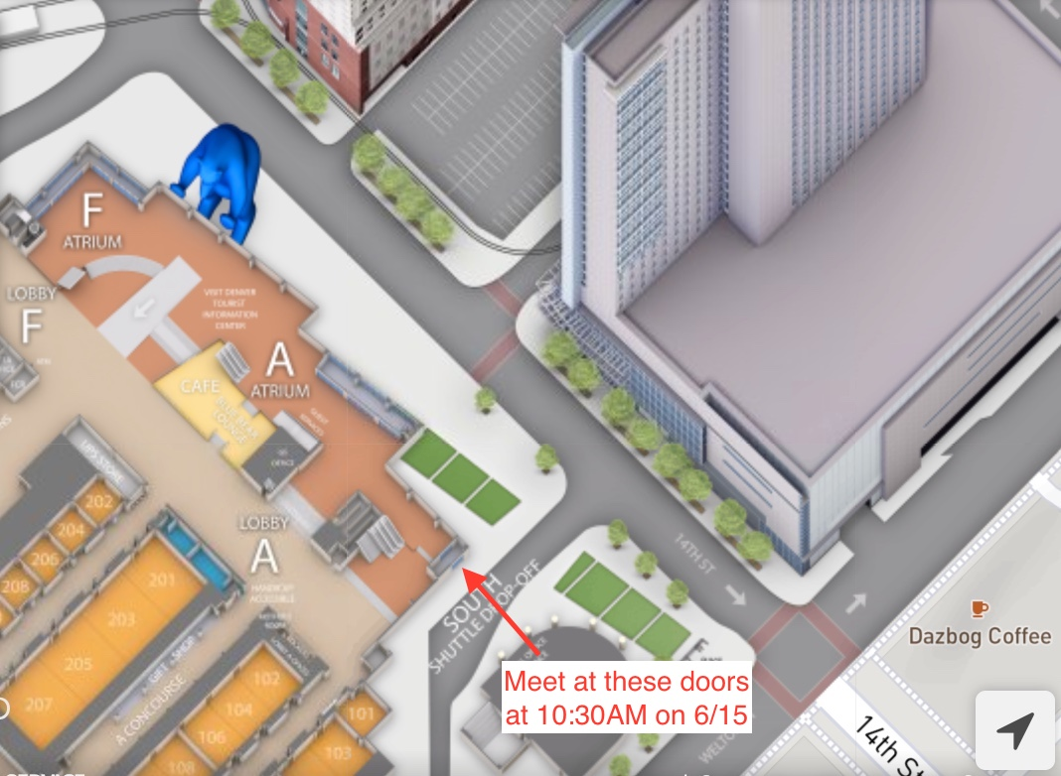  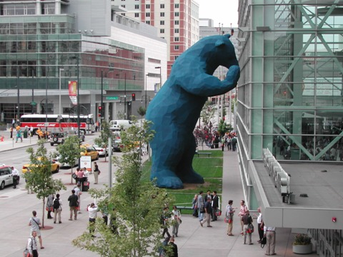  Friday, June 15th  Experience The comix!  Event Description Heading  Experience the Comix (ETC), offered in partnership with Illegal Pete’s restaurants, provides qualifying middle and high school students with complimentary badges to Denver Comic Con with the goal of helping them experience pop culture as a fun, engaging educational tool. This year’s ETC session will take place on Friday, June 15th, 2018 from roughly 10 a.m. to 5 p.m. MT. | Denver Comic Con’s Experience the Comix  ────  Our goal is to provide an inspiring cultural and educational opportunity that will open minds to new, potential career opportunities!  ────  Chaperones:  1. Kristy Cooley  2. David Wishart  3. Jaime Endlich  4. Sabrina Getto  5. TBD  ────  Organizer:  Andrew Holder  ────  You Have Room for Another One Here!  Where?  This year’s ETC session will be held at the Colorado Convention Center (700 14th St. Denver, CO 80202) during the first day of Denver Comic Con 2018. Important note: We cannot provide transportation to and from the event!
Where will we meet on Friday, June 15th?

