Name: _________________________________________________ Date: __________ Period: _____ Score: __________

Michael Wood’s In Search of Beowulf

Directions: After viewing the BBC documentary, Michael Wood: In Search of Beowulf, provide concise, elegantly-written responses using good grammar and punctuation to the questions below.

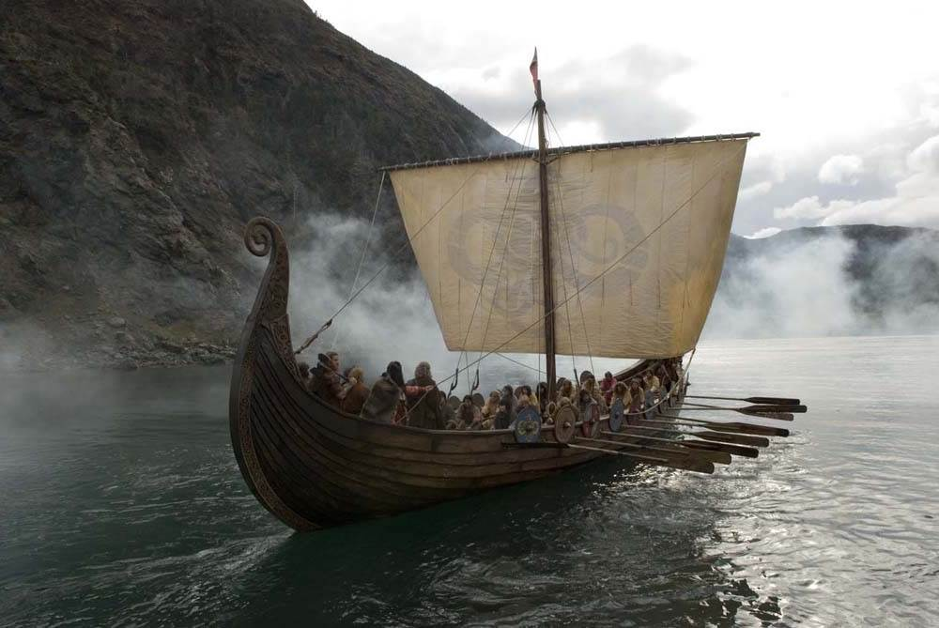1. Based on what you saw in the BBC documentary, what literary, historical, or cultural features makes Beowulf and immigrant or migration saga?

2. How is the Beowulf text, “caught between Anglo-Saxon paganism and early English Christianity?”

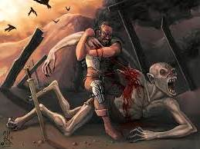3. Why do you think Beowulf’s creator made the first literary text in the canon of English language literature an epic adventure tale and not a romance, tragedy, comedy, or some other genre?

4. Consider what the documentary revealed about Sutton Hoo, the East Anglian ship burial and treasure hoard archeological site. How is the presumed cultural history of this site connected to the Beowulf text?

5. What was the nature of the “spirit war” that was raging when Beowulf was first created and performed? How might early English Christians use this text to support their efforts to convert pagans?

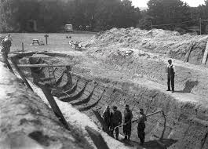

6. What do you think Michael Wood meant when he argues that we as contemporary readers can see our own contemporary “ironical, self-deprecating, and tough-minded” speech in the medieval English of the Beowulf text?

