Name: ___________________________________________________________ Date: __________ Period: _____Score: __________

Studio 360: Superman

Directions: As you listen to the Studio 360 radio show about the origins and history of Superman, answer the questions below in the space provided. Be sure to write in complete sentences using good grammar, spelling, syntax, and punctuation. Once finished, complete the SCR on the back.
[Sidebars are great for calling out important points from your text or adding additional info for quick reference, such as a schedule.
They are typically placed on the left, right, top or bottom of the page. But you can easily drag them to any position you prefer.
When you’re ready to add your content, just click here and start typing.]
How is superman unique among superheroes?
- What three specific words are used to describe Superman?

- What is Superman’s job and what is the struggle about it?

- What is the definition of krypton?

- What was Superman’s Hebrew name?

- How did the civilization end? What happened to Superman after his civilization ended?

- What was the name of the two men who helped create Superman?

- How much did DC pay to buy Superman from the two men?
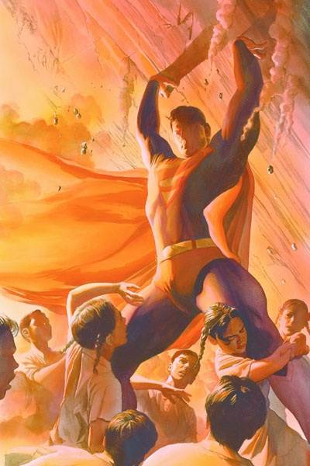

- What was the issue that occurred later on between the two men and DC corporate?

- What source of multimedia did Superman start off on?

- What occurred in 1952 that was significant for Superman and multimedia?

Prompt: Does the world really need Superman? On the lines provided below, compose a well-written, argumentative SCR over the prompt. Use the formula you have been taught for the college essay and make sure you include at least 3 pieces of concrete evidence to support your argument. Avoid using personal pronouns as I, you me, we, us, our, my, etc., as well as interrogative sentences. If you run out of room, you may complete your essay on a separate sheet of notebook paper.

________________________________________________________________________________________________________________________________________________________________________________________________________________________________________________________________________________________________________________________________________________________________________________________________________________________________________________________________________________________________________________________________________________________________________________________________________________________________________________________________________________________________________________________________________________________________________________________________________________________________________________________________________________________________________________________________________________________________________________________________________________________________________________________________________________________________________________________
____________________________________________________________________________________________________________________________________________________________________________________________________________________________________________________________________________________________________________________________________________________________________________________________________________________________________________________________________________________________________________________________________________________________
____________________________________________________________________________________________________________________________________________________________________________________________________________________________________________________________________________________________________________________________________________________________________________________________________________________________________________________________________________________________________________________________________________________________
____________________________________________________________________________________________________________________________________________________________________________________________________________________________________________________________________________________________________________________________________________________________________________________________________________________________________________________________________________________________________________________________________________________________
____________________________________________________________________________________________________________________________________________________________________________________________________________________________________________________________________________________________________________________________________________________________________________________________________________________________________________________________________________________________________________________________________________________________
____________________________________________________________________________________________________________________________________________________________________________________________________________________________________________________________________________________________________________________________________________________________________________________________________________________________________________________________________________________________________________________________________________________________
____________________________________________________________________________________________________________________________________________________________________________________________________________________________________________________________________________________________________________________________________________________________________________________________________________________________________________________________________________________________________________________________________________________________
____________________________________________________________________________________________________________________________________________________________________________________________________________________________________________________________________________________________________________________________________________________________________________________________________________________________________________________________________________________________________________________________________________________________
____________________________________________________________________________________________________________________________________________________________________________________________________________________________________________________________________________________________________________________________________________________________________________________________________________________________________________________________________________________________________________________________________________________________

